

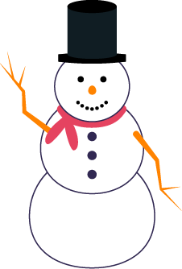

To:

From:

Date:

RE: Daycare Holiday Closing Information

It's that time of year again when [Daycare Name] closes for the holidays. We’re notifying you so you can make alternative arrangements for your child during this period if necessary.

We will close on [Date and Time] and reopen again next year on [Date and Time]. Please settle all accounts in full by [Date and Time] to avoid penalty fees.

May you and your family have a happy holiday season.

Sincerely,

[Daycare Name]