Box Tops for K-12 Schools
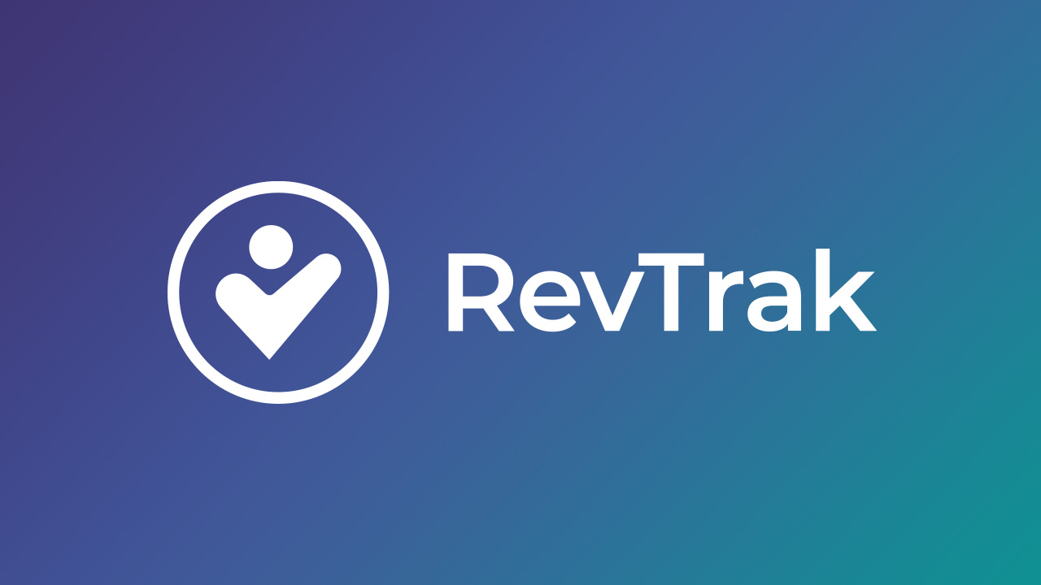

Phase 1: Getting Started

Program Registration
☐ Visit BoxTops4Education.com to create a school account
☐ Verify your school is enrolled in the program
☐ Designate a Box Tops Coordinator for your school
☐ Set up coordinator login credentials
☐ Review program rules and guidelines
☐ Download the Box Tops mobile app

Initial Planning
☐ Form a Box Tops committee or recruit parent volunteers
☐ Set collection goals for the school year
☐ Determine how funds will be used (communicate this to parents)
☐ Create a timeline for collection campaigns
☐ Identify storage space for physical Box Tops (if still collecting)

Phase 2: Communication Setup

Materials Preparation
☐ Create informational flyers about the program
☐ Design collection box labels
☐ Prepare sign-up sheets for volunteers
☐ Draft initial parent communication letter
☐ Create social media graphics (if applicable)

Communication Channels
☐ Add Box Tops information to school newsletter
☐ Update school website with Box Tops information
☐ Set up email distribution list for updates
☐ Plan announcement for school assembly or PA system
☐ Create bulletin board display

Phase 3: Collection System Implementation

Digital Collection Setup
☐ Promote Box Tops mobile app to families
☐ Create instructions for scanning receipts
☐ Set up classroom or grade-level competitions
☐ Establish receipt scanning volunteers (if needed)
☐ Create tracking system for digital submissions

Physical Collection (if applicable)
☐ Place collection boxes in strategic locations
☐ Set up classroom collection containers
☐ Create collection schedule
☐ Assign volunteers for sorting and counting
☐ Establish submission deadlines

Phase 4: Launch Activities

Kickoff Event
☐ Schedule launch date
☐ Plan kickoff assembly or event
☐ Prepare demonstration of app usage
☐ Distribute initial communication materials
☐ Launch any competition or incentive programs

Family Engagement
☐ Host Box Tops information session for parents
☐ Create take-home packets with instructions
☐ Set up information table at school events
☐ Recruit room parents as Box Tops champions
☐ Share list of participating products/brands

Phase 5: Ongoing Management

Regular Tasks
☐ Send monthly reminder communications
☐ Update collection totals on displays
☐ Submit physical Box Tops before expiration
☐ Monitor digital submission progress
☐ Recognize top contributors
Volunteer Coordination
☐ Schedule regular volunteer sessions
☐ Train new volunteers on procedures
☐ Maintain volunteer contact list
☐ Send volunteer appreciation notes
☐ Coordinate volunteer schedule

Phase 6: Tracking and Reporting

Progress Monitoring
☐ Track earnings by classroom/grade
☐ Monitor progress toward goals
☐ Create visual progress displays
☐ Share updates at PTA/PTO meetings
☐ Report earnings to school administration

Financial Management
☐ Set up tracking for payments received
☐ Coordinate with school financial office
☐ Document how funds are allocated
☐ Maintain records for reporting
☐ Share impact stories with families

Phase 7: Motivation and Recognition

Incentive Programs
☐ Design classroom competitions
☐ Create individual recognition system
☐ Plan celebration for reaching goals
☐ Implement monthly challenges
☐ Establish prizes or rewards

Communication of Success
☐ Share success stories in newsletters
☐ Post updates on social media
☐ Create thank you communications
☐ Highlight top participating classrooms
☐ Celebrate milestone achievements

Phase 8: Year-End Activities

Program Evaluation
☐ Calculate total earnings for the year
☐ Survey families for feedback
☐ Evaluate volunteer participation
☐ Document lessons learned ☐ Plan improvements for next year

Transition Planning
☐ Recruit next year's coordinator (if changing)
☐ Create transition documentation
☐ Archive important materials
☐ Submit final Box Tops before summer
☐ Communicate summer collection options
Important Reminders
Box Tops earnings are deposited directly into your school's account twice per year
•
Digital submissions through the app are the primary method now
•
Traditional Box Tops clips have expiration dates - submit before they expire
•
Keep families informed about what the funds support
•
Make participation easy and fun for maximum engagement
•

